PRESS RELEASE
A Joyous Show for Troubled Times heading to Edinburgh Festival Fringe
Derbyshire-based arts organisation Artisan Creative are taking their unique and uplifting show to world-renowned Edinburgh Festival Fringe in August.
Mischievous, subversive, fun and fizzing with wisdom How to Survive and Thrive in an Impossible World - with a piano! is an invitation to stand back and laugh at a world that is quite clearly bonkers, and take a timeout to realise a better way of dealing with it. The team remarks: “Almost impossible to describe, but this sums it up: an interactive, wellbeing, musical show thingy!”
Based upon the acclaimed book of the same name by award-winning psychologist, author and songsmith, Steve Bonham, the show was developed with support from Arts Council England by Steve and Chris ‘the Bishop’ Lydon, and had pilot performances for NHS staff at University Hospitals of Derby and Burton.
The vision for the show – “liberating happiness and wellbeing, one audience at a time!” – begins in earnest with Edinburgh audiences, and the team hope to catch the eye of arts and community venue programmers from around the country during the run, as a springboard for touring the show nationally later in 2023 and 2024.
The show runs at Greenside @ Infirmary Street, at 13.50, from Friday 4 August to Saturday 19 August (not 13 Aug).
Buy tickets from bit.ly/HTSATfringetix
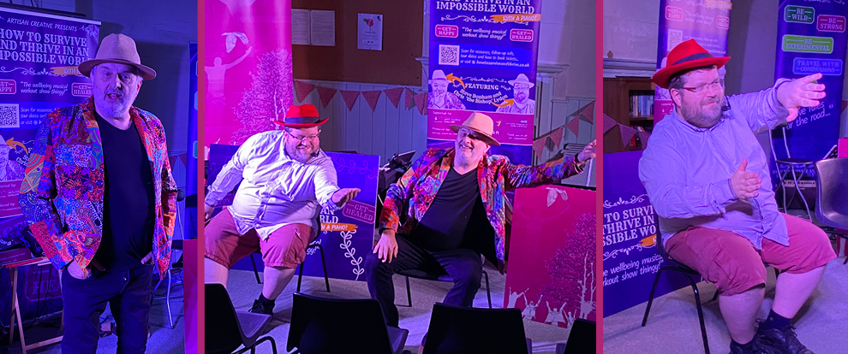
More details at htsat.co.uk

The Bishop’s Mystery Box: a unique fundraising approach
To support the show’s run at the prestigious Edinburgh Festival Fringe, the team are offering a unique fundraising approach for supporters. Anyone who donates £30 or more will receive a “Bishop’s Mystery Box”. They’re not saying exactly what will be in it – as then it wouldn’t be a mystery! - but it will contain a specially curated collection of items all based on the theme: Get Happy, Get Healed.
Chief amongst the items is a "mystery envelope", which might include anything from the Bishop’s secret beignet recipe, to a unique offer to have a house concert in your living room, or various delights in between!
Get your Mystery Box here: artisan-creative.com/shop/p/mysterybox
- ENDS -
The story behind the show
The original book, How To Survive and Thrive in an Impossible World, published by Artisan Creative, was written during lockdown by Steve Bonham, an author, songwriter and award-winning psychologist. It has been described as “challenging, funny, radical and unlike any other ‘how to’ book you have ever read!”.
Prompted by his own experience of how exhausted and stressed he found the NHS staff were whilst he was receiving treatment for cancer, Steve saw a need for an innovative way to break through the permafrost of helplessness in which so many of us are trapped. He came up with the idea of the performance which celebrated our humanity, made us laugh, whilst gently facilitating the onboarding of critical survival skills and ideas.
Steve worked with long-time collaborator, Chris ‘the Bishop’ Lydon, a creative producer, musician and composer to create the new and innovative show.
The show was developed in 2022 with support from Arts Council England, Air Arts and University Hospitals of Derby and Burton. Passionate about the power of the arts to inspire and heal, Steve and Chris are bringing the show to Edinburgh to reach new audiences and as a springboard for a national tour later in 2023 and 2024, focussing on studio theatres, workplaces, community venues and festivals. In fact, wherever people are looking for an antidote for these strange times!
What can the audience expect? Laughter, great stories, wonderful songs, gentle audience participation, including some dancing, inspiring new ideas, and to leave with a smile on their face and an uplifted spirit.

Background
Artisan Creative
Artisan Creative develops distinctive books, recordings and performances, including new theatre pieces, gigs, concerts and festivals, all celebrating the 'extraordinary stories of ordinary folk', rooted in the values of craft, authenticity, inspiration and a love of the raw materials used. Based on over 30 years of experience of working with professional and non-professional collaborators, they have delivered everything from large-scale community projects to intimate solo performances.
artisan-creative.com
Steve Bonham
Steve Bonham is an award-winning psychologist, writer, composer and performer. As well as How to Survive and Thrive in an Impossible World, he has written several other books including: Stumbling Over Eden (about a trek from the top of the Atlas Mountains to the Sahara Desert), A Beautiful Broken Dream (about the Southern States of the USA) and A Little Nostalgia for Freedom (an exploration of human restlessness and the wandering spirit). As a songwriter he is a proud member of the legendary band, The Long Road, and has also released several solo albums, the latest being Standing Stones set free in 2022.
Chris ‘the Bishop’ Lydon
Chris is a musician, composer and creative producer, playing piano and tuba across the UK and Europe, in jazz, Americana, folk and classical worlds. Producing projects with the Hallé orchestra, National Youth Orchestra of Great Britain, performing at Glastonbury Festival, Bestival, at venues such as Royal Albert Hall, Royal Festival Hall, working at studios such as Woodworm Studios, Toe Rag Studios and Riverside Studios, with commissions from Manchester International Festival.

Contacts and further information
Steve Bonham steve@artisan-creative.com 07711 788248
Chris Lydon chris@artian-creative.com 07816 996769

More about How To Survive and Thrive in an Impossible World – with a piano! at htsat.co.uk
More about Artisan Creative at artisan-creative.com

Photographs, logos etc. available from htsat.co.uk/about/press

